AAW

AWS ADVANCED ASSIGNMENT-4

DAY 9-10

ARAVIND G KUMAR

**Project 1: Elastic Load Balancer**

Task 1: Create a Linux instances

* Go to Ec2.
* Select launch instance.
* Create Linux instances.

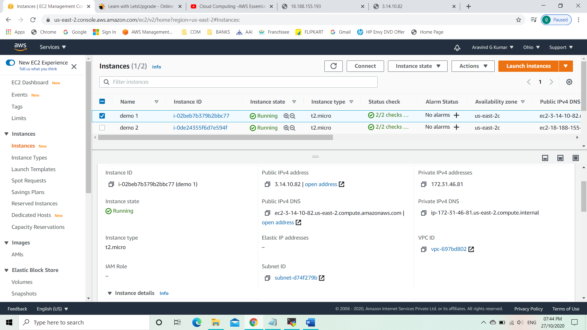

Task 2: Connect the instance using Mobaxterm and launch it.

* Copy the public ip.
* Open the Mobaxterm.
* Click on sessions.
* Click on SSH.
* Paste the public IPv4 for remote host.
* Click on advanced SSH settings and give the private key.
* Run the codes.

sudo su

yum install httpd

cd /var/www/html

pwd

vi index.html

i

<form action="action_page.php" method="post">

<div class="imgcontainer">

<img src="img_avatar2.png" alt="Avatar" class="avatar">

</div>

<div class="container">

<label for="uname"><b>UserID</b></label>

<input type="text" placeholder="Enter Username" name="uname" required>

<label for="psw"><b>Passkey</b></label>

<input type="password" placeholder="Enter Password" name="psw" required>

<button type="submit">Login</button>

<label>

<input type="checkbox" checked="checked" name="remember"> Remember me

</label>

</div>

<div class="container" style="background-color:#f1f1f1">

<button type="button" class="cancelbtn">Cancel</button>

<span class="psw">Forgot <a href="#">password?</a></span>

</div>

</form>

Esc: wq

more index.html

service httpd start

service httpd status

* Connect the instance using the Public IPv4.

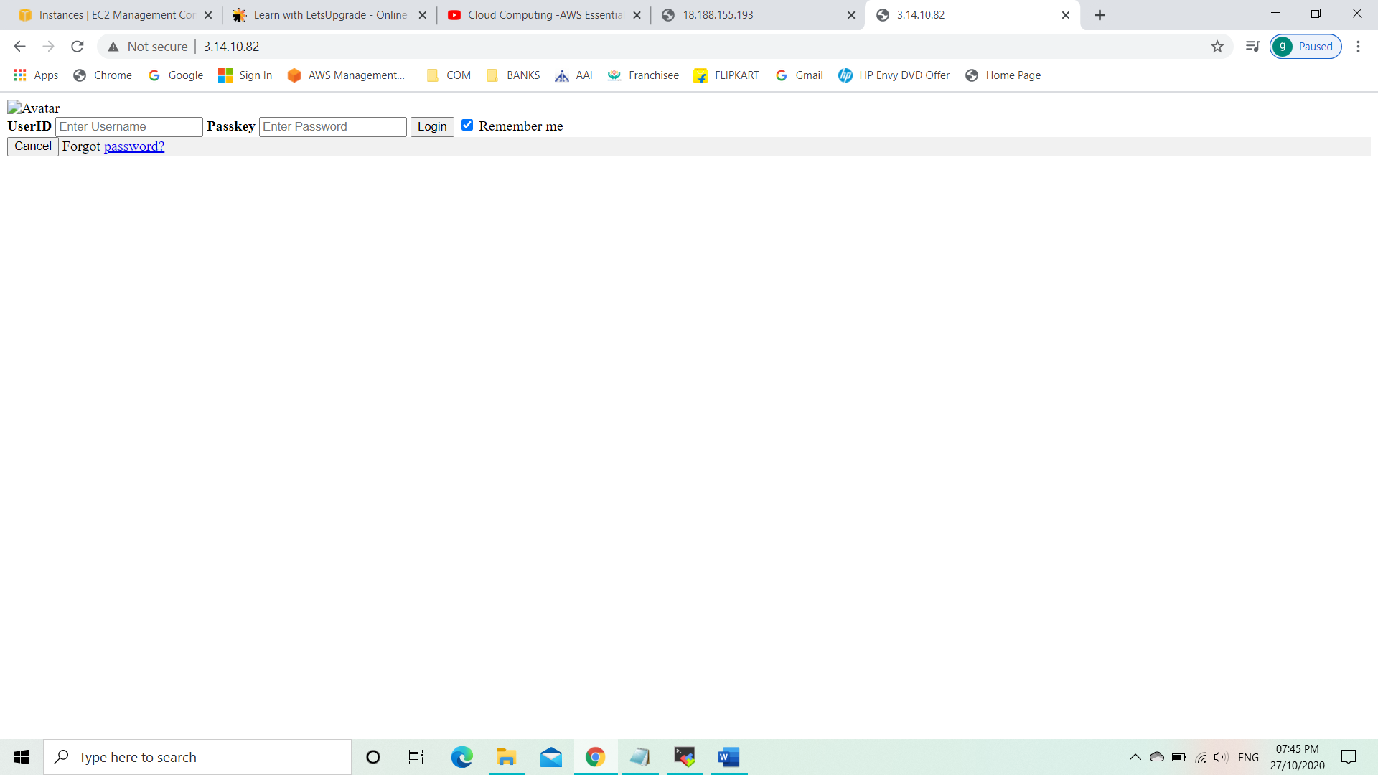Task 3: Create a Linux instances 2

* Go to Ec2.
* Select launch instance.
* Create Linux instances 2.

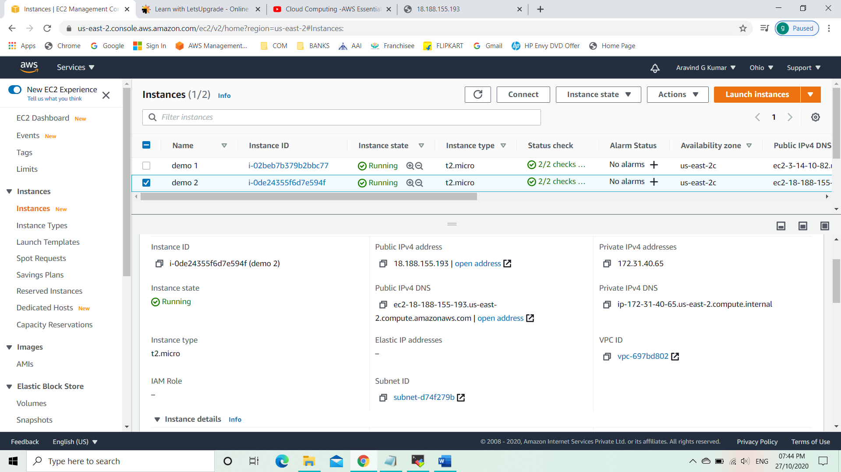

Task 4: Connect the instance using Mobaxterm and launch it.

* Copy the public ip.
* Open the mobaxterm.
* Click on sessions.
* Click on SSH.
* Paste the public IPv4 for remote host.
* Click on advanced SSH settings and give the private key.
* Run the codes.

sudo su

yum install httpd

cd /var/www/html

pwd

vi index.html

i

<form action="action_page.php" method="post">

<div class="imgcontainer">

<img src="img_avatar2.png" alt="Avatar" class="avatar">

</div>

<div class="container">

<label for="uname"><b>Username</b></label>

<input type="text" placeholder="Enter Username" name="uname" required>

<label for="psw"><b>Password</b></label>

<input type="password" placeholder="Enter Password" name="psw" required>

<button type="submit">Login</button>

<label>

<input type="checkbox" checked="checked" name="remember"> Remember me

</label>

</div>

<div class="container" style="background-color:#f1f1f1">

<button type="button" class="cancelbtn">Cancel</button>

<span class="psw">Forgot <a href="#">password?</a></span>

</div>

</form>

Esc: wq

more index.html

service httpd start

service httpd status

* Connect the instance using the Public IPv4.

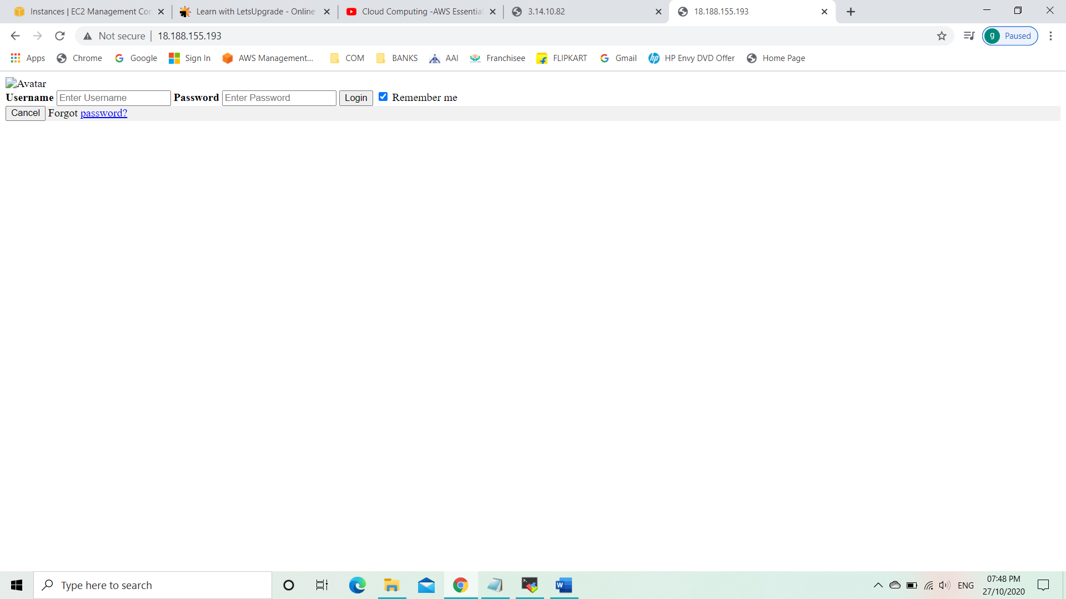

Task 5: Creating an ELB.

* Go to Elastic Load Balancer.
* Click on create Load Balancer.
* Click on application load balancer.
* Configure the load balancer.
* Create the Load Balancer.

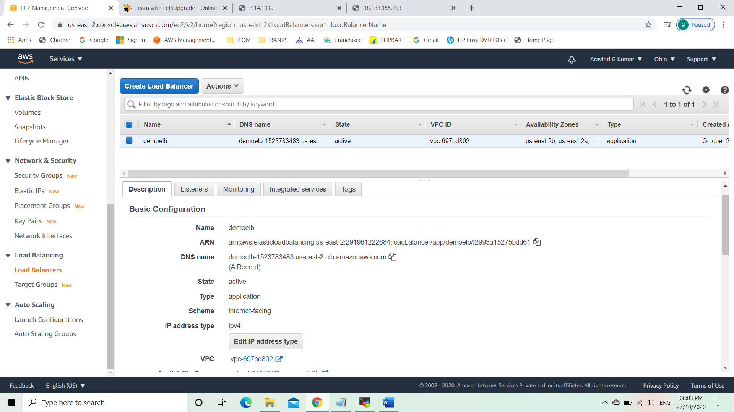

* Check whether the ELB is functioning or not.

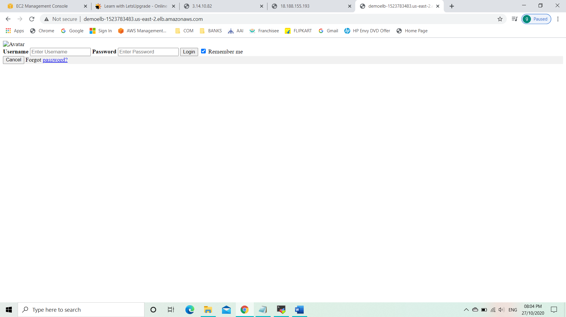

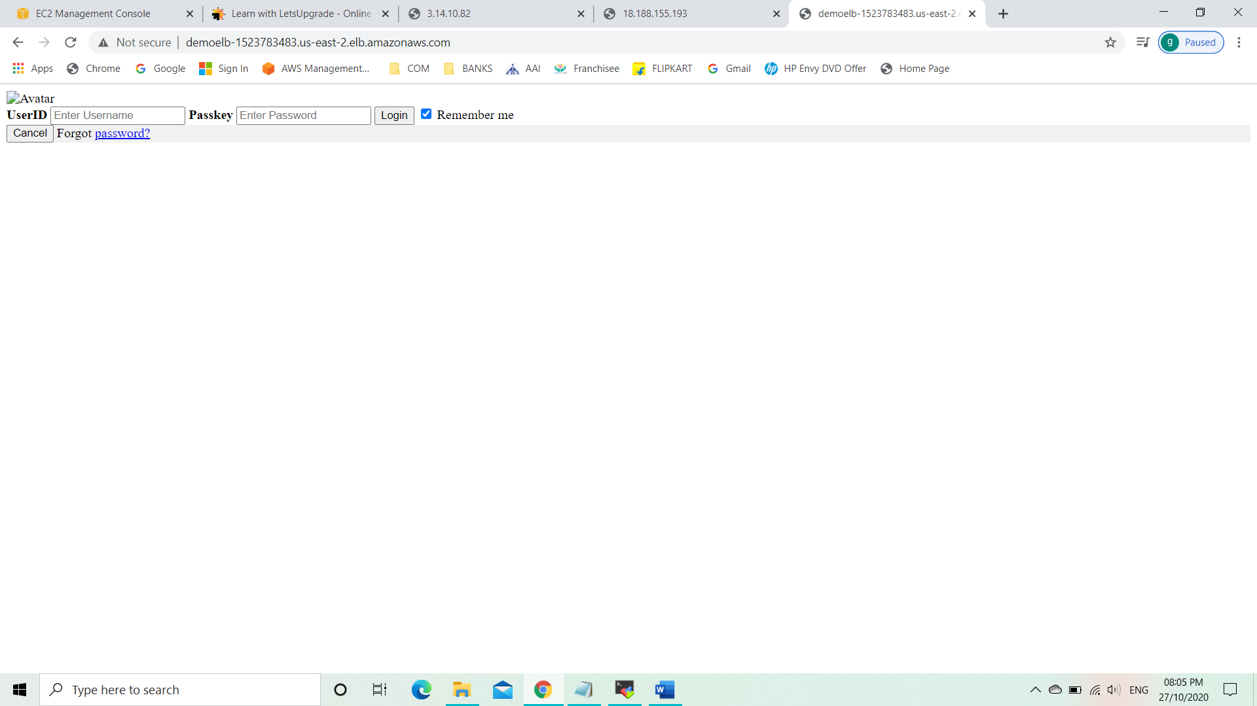

**Project 2: Creating a User Pool in AWS Cognito.**

* Select Cognito in the service tab.
* Select the region as North Virginia.

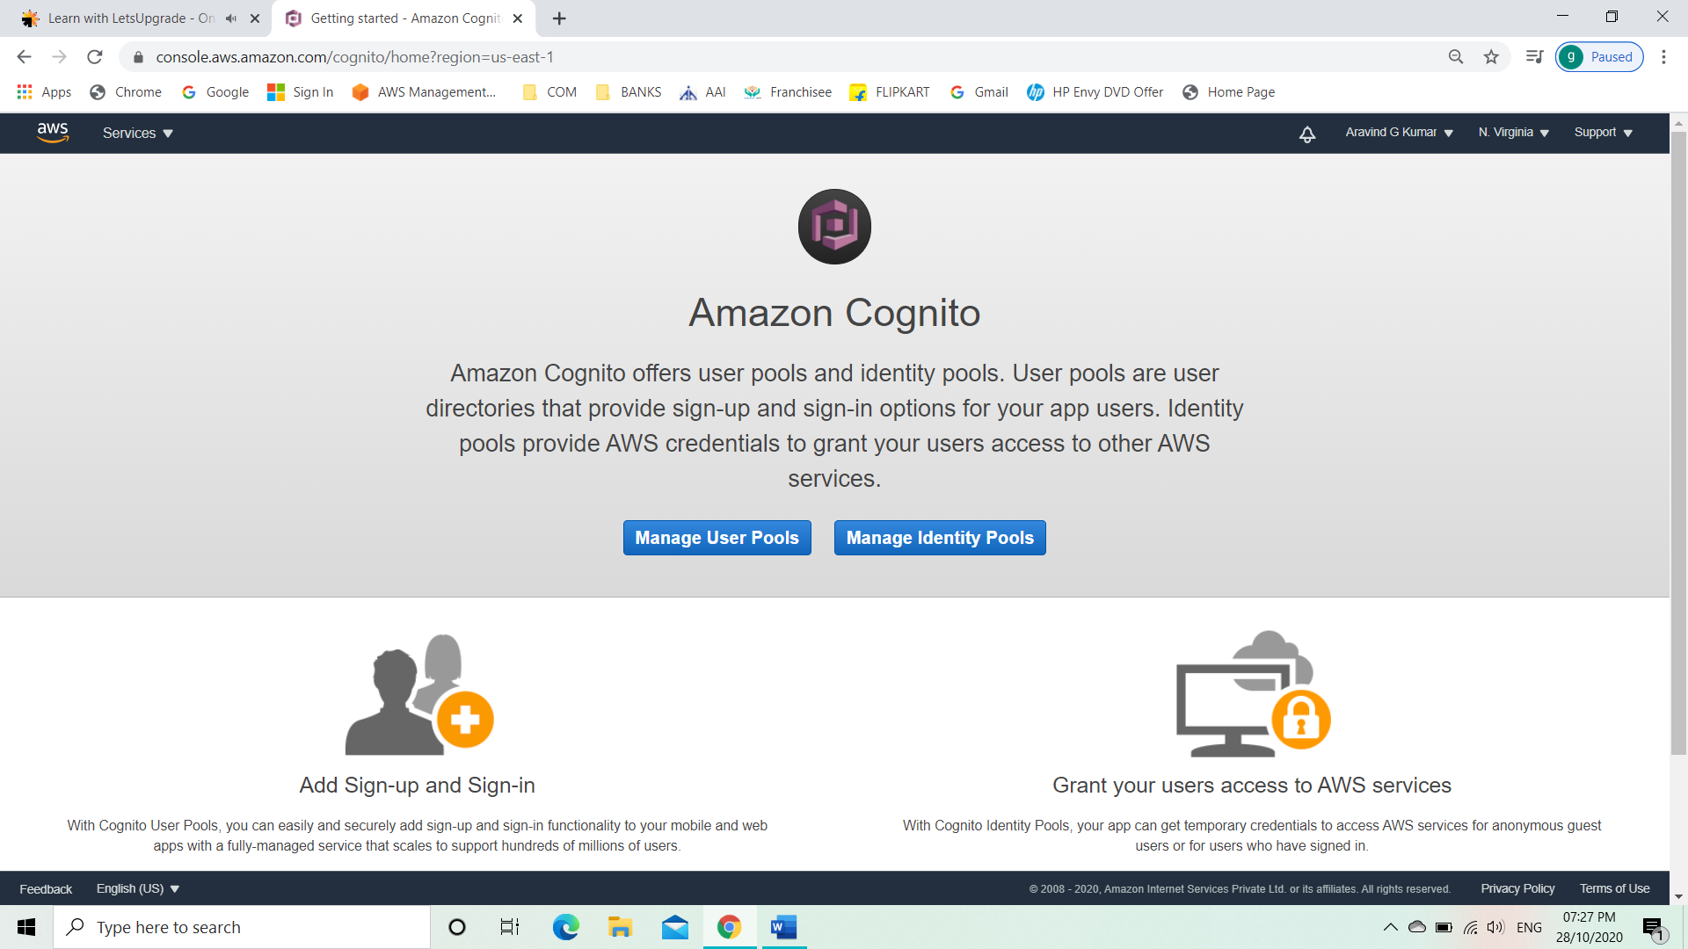

* Click on manage user pools.
* Click on create user pools.

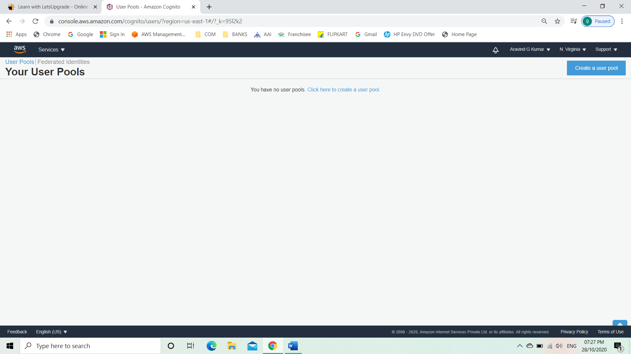

* Give your user pool a name.

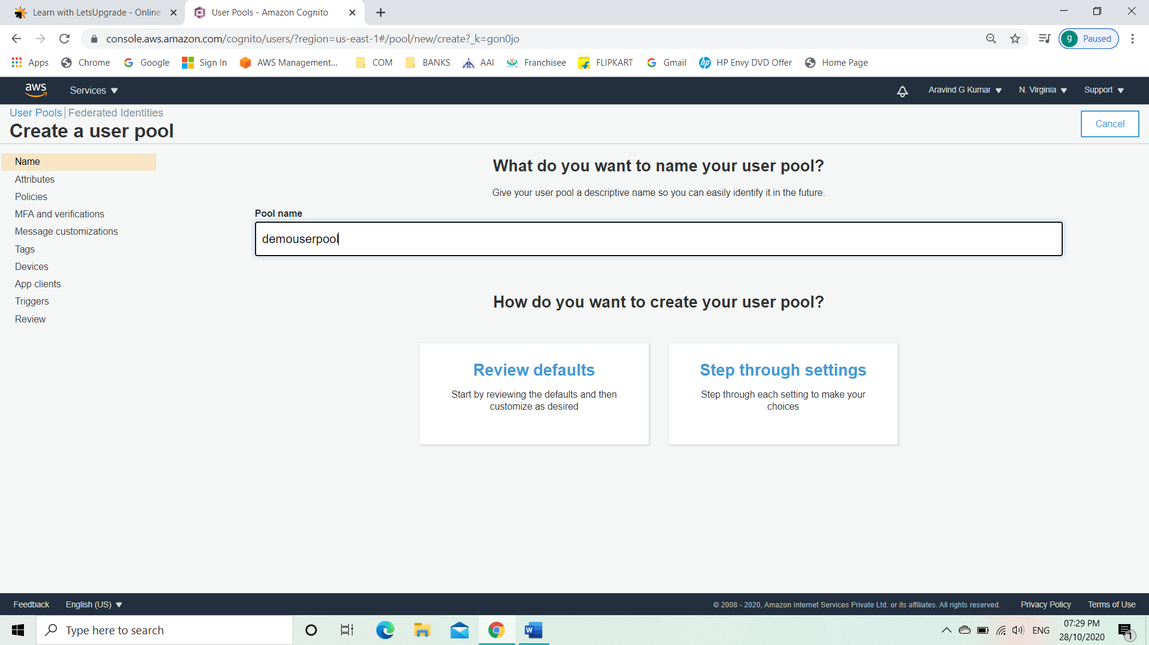

* Click step through settings.
* Click on allow email address.
* Select the required attributes.

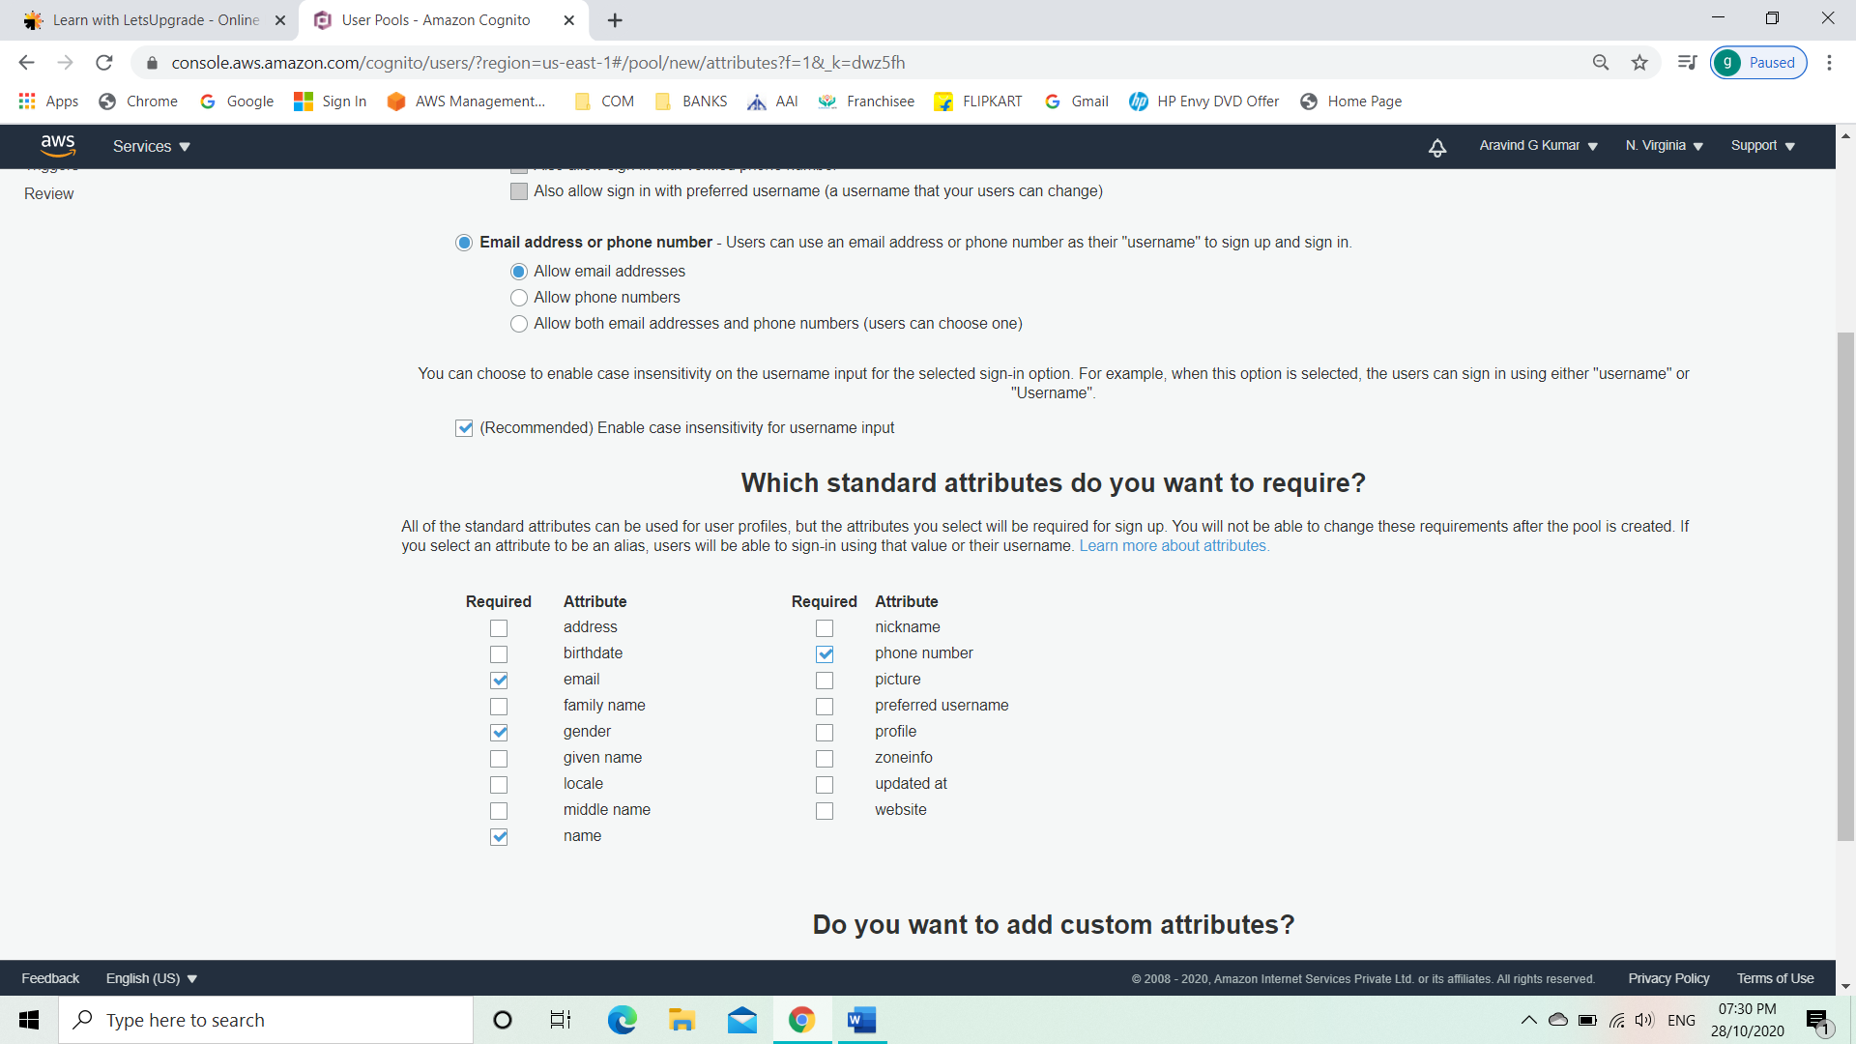

* Click on next step.
* Give minimum length password.
* Click only allow administrator to create users.

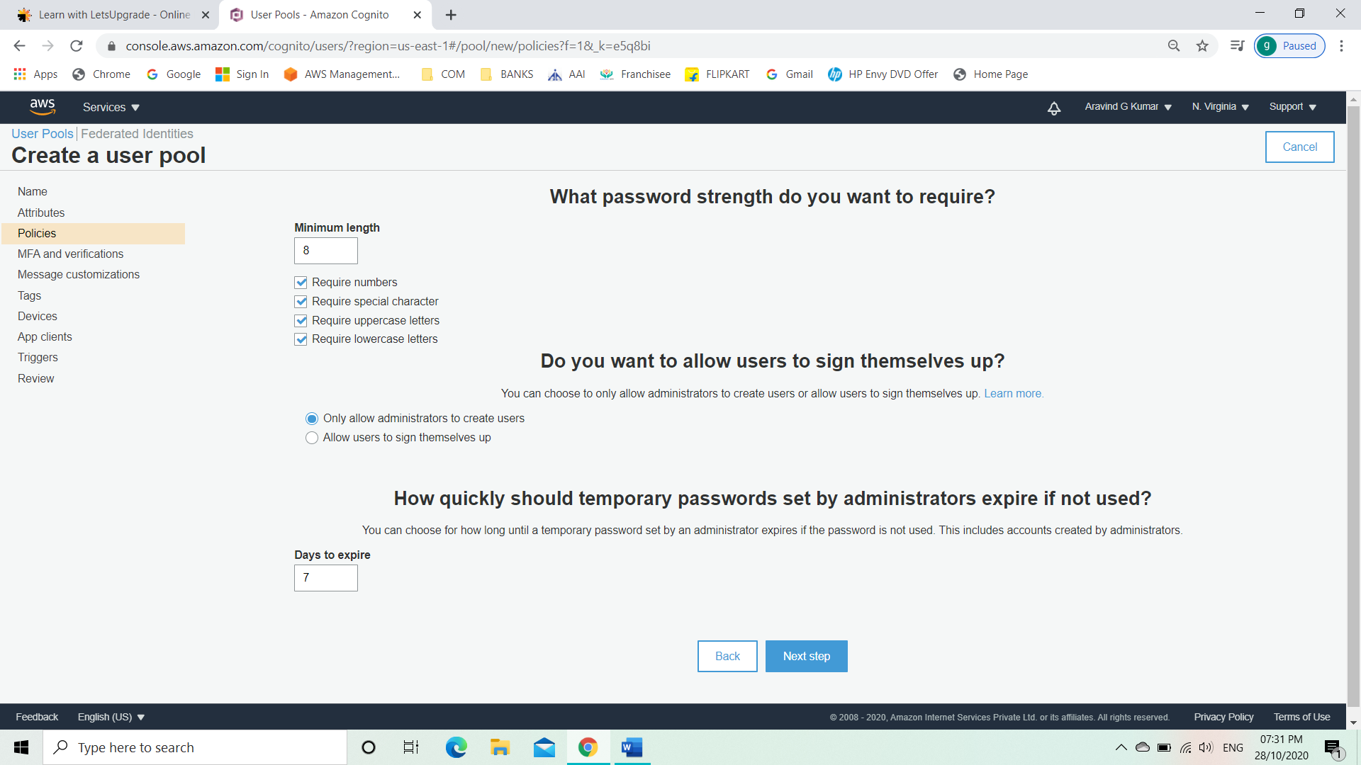

* Click on next.
* Add tags.

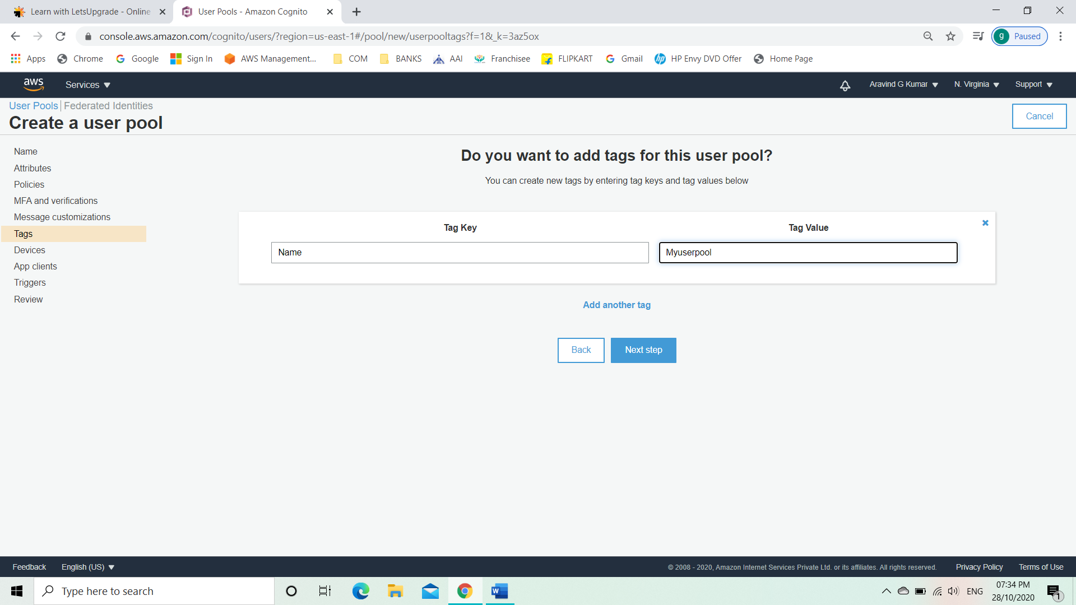

* Go to review page.

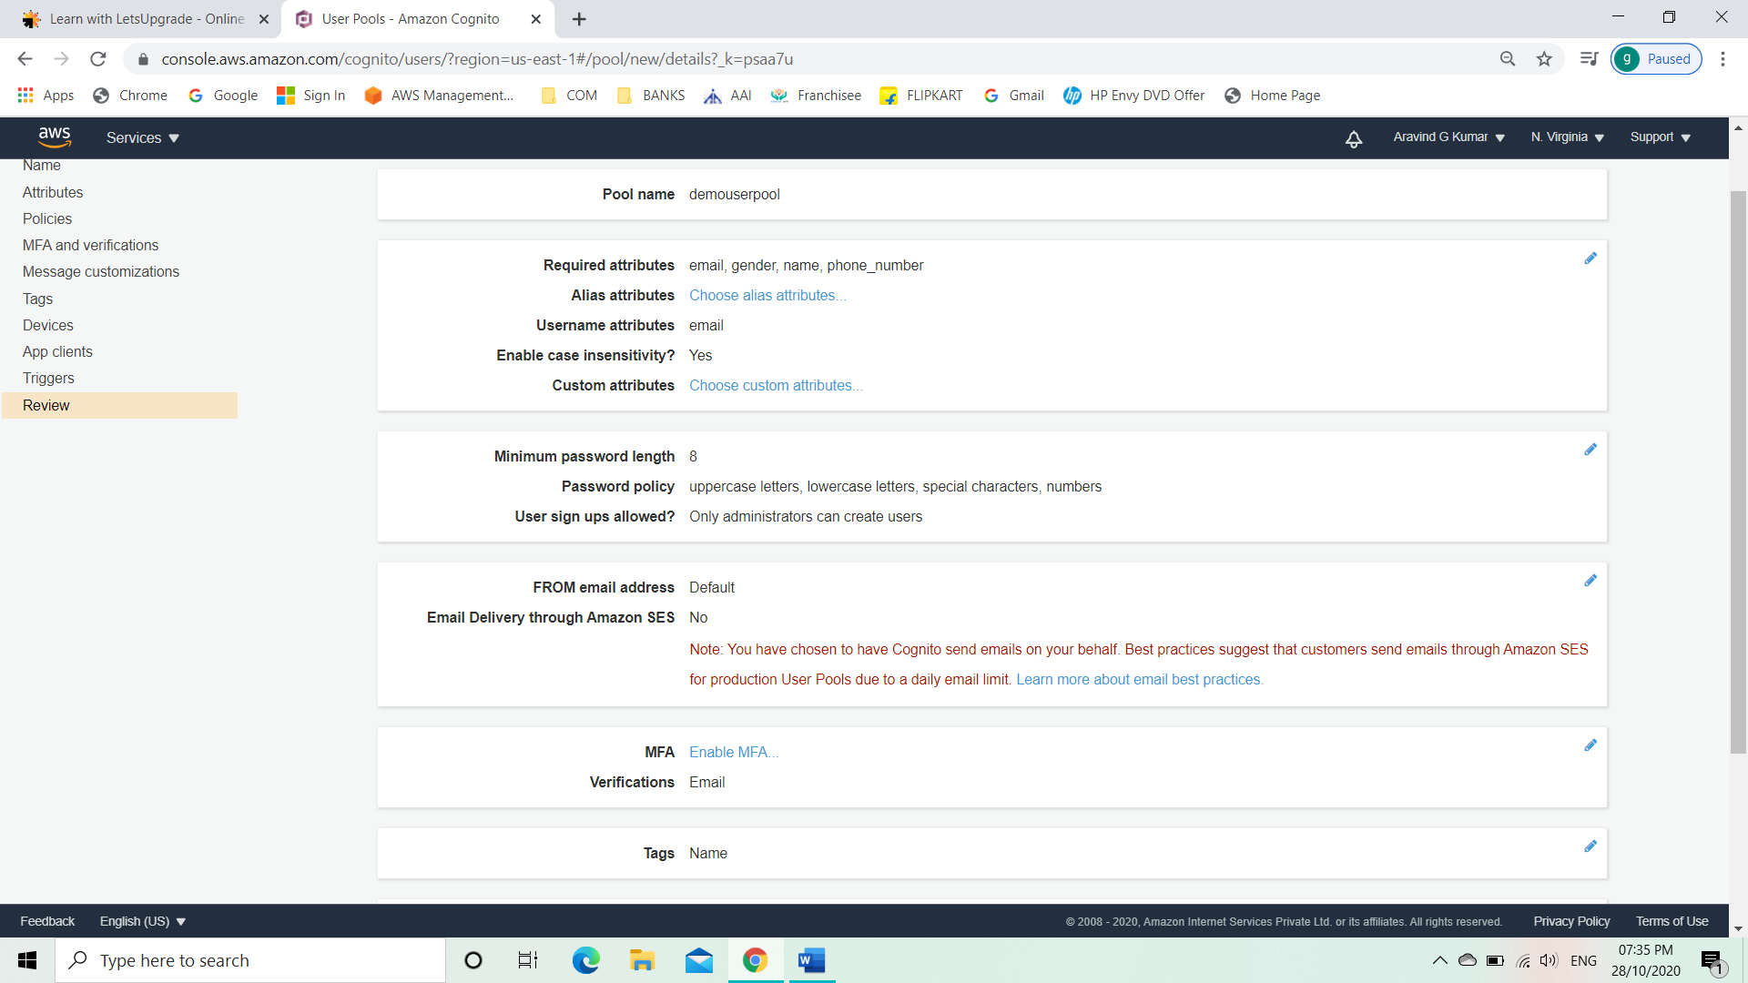

* Click on create pool.

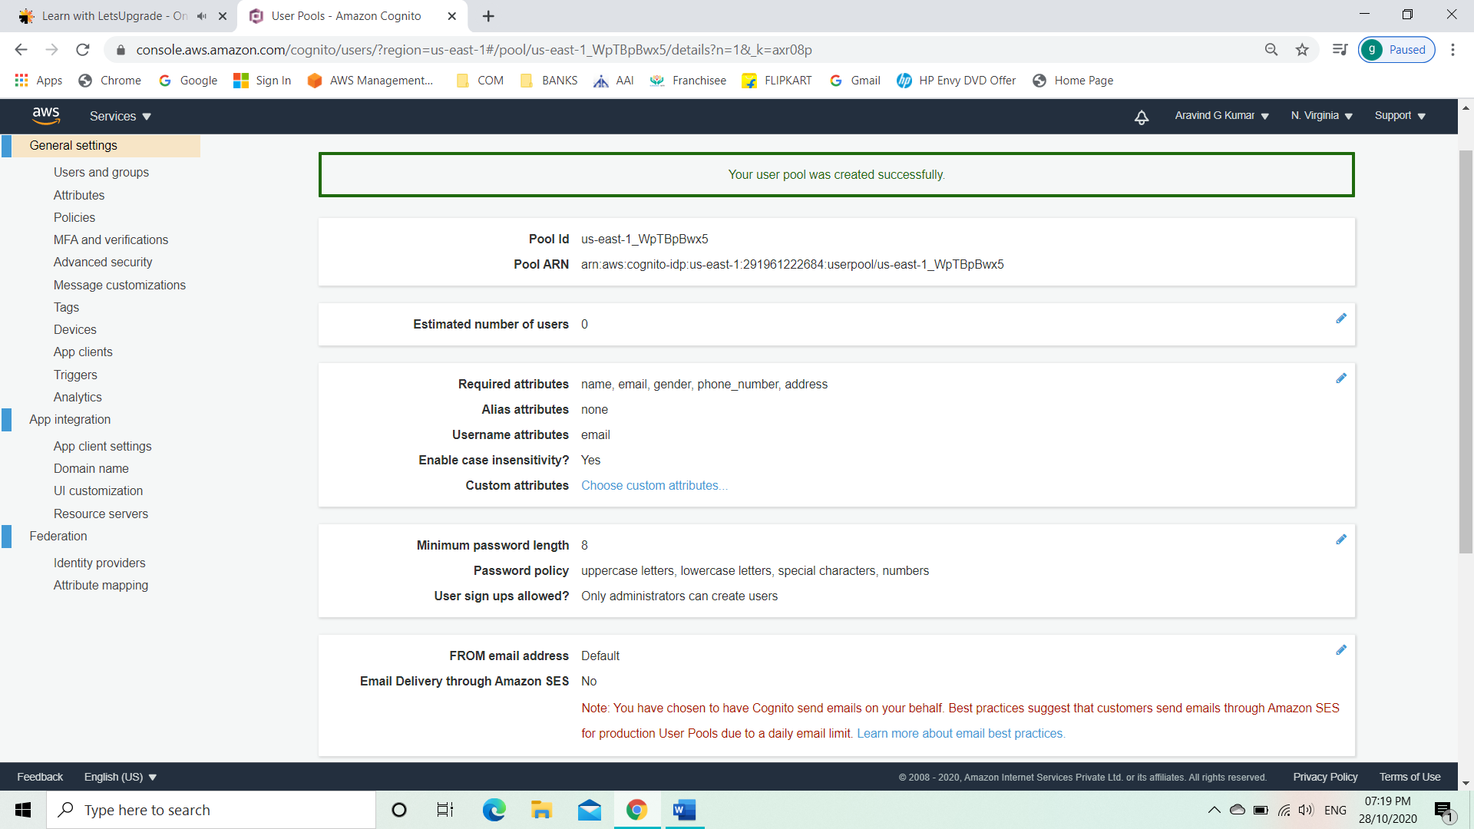

* Click on users and group.

